Assignment 1

Input output for entering employee

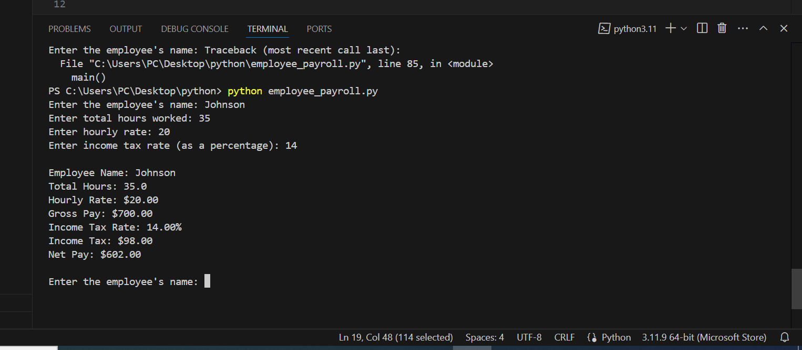

Total number of employees entered with their net pay

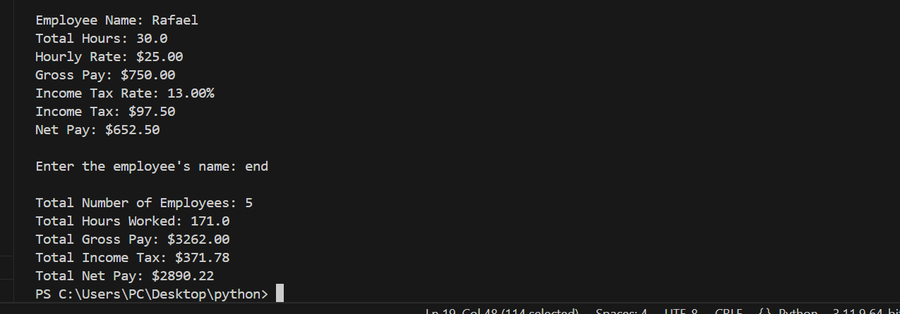

Reflection

The assignment was a great opportunity to practice basic Python concepts such as loops, functions, and input handling. The challenge was ensuring input validation and handling calculations efficiently. Overall, the process helped reinforce my understanding of Python programming.